# DASHBOARD

The **Dashboard** tab uses a collection of windows to provide a comprehensive view of all your *Problems*, *Encounters*, *Reports*, *Lab Results*, *Medications*, *Allergies*, *Immunizations*, and *Provider Information* contained within the HIE. By default, outpatient lab results and reports are available 48 hours after they are final. Inpatient results are available 36 hours after discharge from the hospital. Some kinds of lab results and reports may not be included—ask your healthcare provider if a result is not displayed.

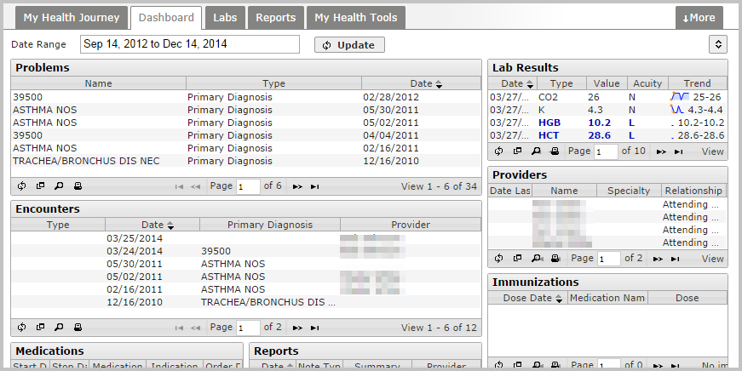

The default *Date Range* displayed is the past two years up to the next three months (to allow for future Encounters, such as a scheduled clinic visit). To filter by a different date range, click on the displayed *Date Range* filter to limit the results to any of the displayed ranges or to specify a start and end date.

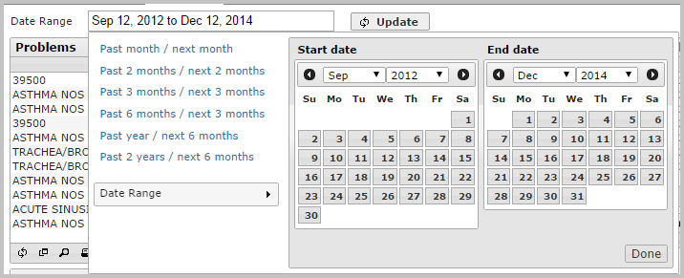

Use the tools in the bottom left corner of each grid to reload, expand, search, or print the list of results.

